WEEK 1

Aim:

Write about file management Commands (5), Process Management Commands (5), Disk Management, Network management Commands (5) with at least 3 options.

Description:

File Management: file management in Unix. All data in Unix is organized into files. All files are organized into directories. These directories are organized into a tree-like structure called the filesystem.

1.Listing Files :

To list the files and directories stored in the current directory



Options

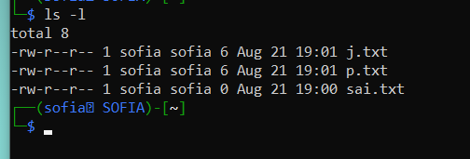

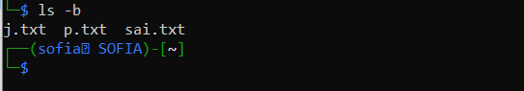



2.Touch : to create files

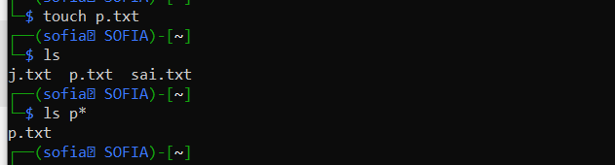

3.Cat : to display the contents of the files



Options :

-b to display line numbers



4.WC :

Counting words in a file

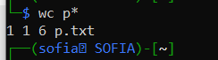

5.CP: copy contents of the file



6. MV : move contents of the code



7. MKDIR : to create folder

8. DIR : to list directory contents

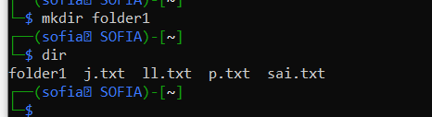

9. rm : deleting files

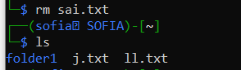

Process Management

1.PS : list running processes



2.top: The top command is a very useful tool for quickly showing processes sorted by various criteria.

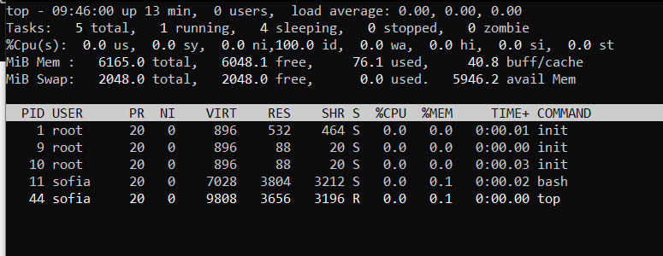

3.KILL: kill a process with specified process ID from console.

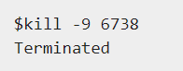

Disk Utilities/communication

1.Ping Utility

The ping command sends an echo request to a host available on the network.:

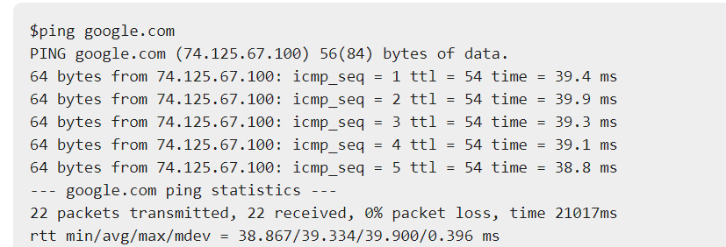

2. FTP.

**ftp** stands for **F**ile **T**ransfer **P**rotocol. This utility helps you upload and download your file from one computer to another computer.

$ftp amrood.com

Connected to amrood.com.

220 amrood.com FTP server (Ver 4.9 Thu Sep 2 20:35:07 CDT 2009)

Name (amrood.com:amrood): amrood

3.TELNET

**Telnet** is a utility that allows a computer user at one site to make a connection, login and then conduct work on a computer at another site.

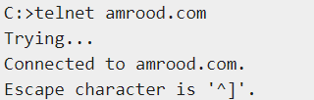

4.Finger:

The **finger** command displays information about users on a given host. The host can be either local or remote.



5.fdisk: View all Disk Partitions in Linux

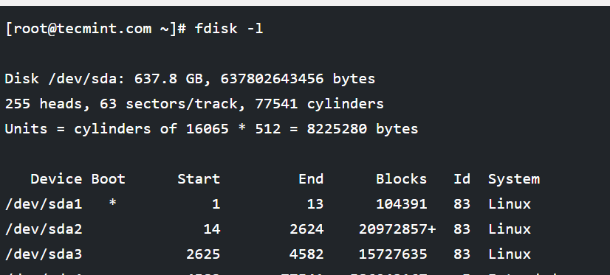

6.DU :  [du](https://www.cyberciti.biz/tips/linux-unix-du-command-examples.html) to displays the file system block usage.

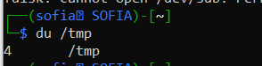

## 7. df: Display Free Disk Space

. 